NAME Quang Huynh

Cloning – An Internet Activity

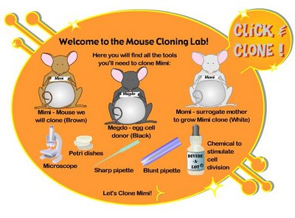

Clone a mouse online! Learn about the facts, myths, and risks behind creating genetic carbon copies.

Site: Genetic Science Learning Center
https://learn.genetics.utah.edu/content/cloning/
Click on CLICK AND CLONE.
Click on MIMI to begin!
Click on Let’s Clone Mimi

Read and follow all direction to answer the questions:

Step 1: Isolate donor cells from Mimi (somatic cell) and Megdo (egg
cell).

Which of the cells extracted is a sex cell? Egg cell

Step 2: Remove and discard the nucleus from the egg cell.

What tool is used to remove the nucleus from the egg cell? A sharp pipette

Step 3: Transfer the somatic cell nucleus into the egg cell.

Why do the new DNA and the egg cell need time to adjust to one another?

The DNA needs to be reprogrammed.

Step 4: Stimulate cell division

This type of cell division is also known as mitosis.
(cell is making exact copies of itself)

Step 5: Implant the embryo into Momi, a surrogate mother.

Differentiation will occur once the embryo is implanted. What occurs during differentiation?

It amount of cells increases and develops into different tissue types.

Step 6: Deliver the baby mouse clone of Mimi

What color do you think the clone will be? Brown

Was your hypothesis correct? YES or NO

Why is the clone this color? The somatic cell’s owner’s color was brown.

----------------------------------------------------------------------------------------------

https://learn.genetics.utah.edu/content/cloning/whyclone/

*Why Clone?
List 4 reasons why we should clone:

- Cloning would help reduce the time needed to make a transgenic animal model. It could help cure diseases easier.

- Cells from clones can help repair diseased organs and tissues.

- Reviving extinct species or endangered species.

- Getting back a dead pet.

https://learn.genetics.utah.edu/content/cloning/cloningornot/
*Is it Cloning? Or not?
Take the test. How did you do? I won seven mammoths. I got all 7 questions correct.

